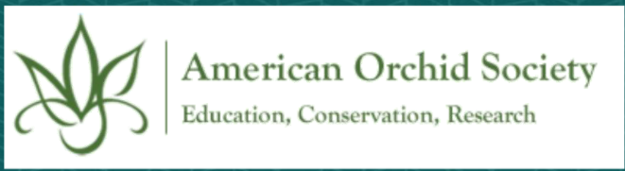
Project Title:
Primary Contact Person:
Role:
Address:
E-mail:
Contact phone #:
Name of organization that agrees to administer funds if awarded:

Executive Summary
Please provide a synopsis of the overall project and goals for which you are seeking AOS funding (maximum 400 words). Note that this summary may be used by the AOS in articles and newsletters to our membership and affiliated societies to highlight and bring awareness to your program/initiative.

Statement of Significance
Briefly describe why this project is important. (maximum 300 words)

Project Scope of Work
Describe the proposed project and its key goals. Please limit this description to 5 pages. Include information about the project design, including methods used to collect and analyze information as applicable.

Regulatory Requirements
Are regulatory and environmental permits required to complete the proposed project? List required permit(s) and indicate their status (need to be applied for, in approval progress, received, etc.).

Schedule
Please provide dates and key events from the start of the project through the anticipated submission of your final report to the AOS. Note: multi-year projects require acceptable progress reports at the conclusion of each funding year for subsequent year funding.

Funding
Please indicate the sources and amounts of additional funding you have secured or requested for the specific project being proposed here.

Project Evaluation
Please describe the evaluation process for the success of your project.

Distribution of Results
Please indicate your plan for dissemination of results.

Application Checklist.
Please email the following to conservation_committee@aos.org:
1. This application (including project title, contact person, executive summary, statement of significance, etc.)
2. Project Scope of Work (up to 5 pages)
3. Budget (see application guidelines and use template below)
4. Resumes or CV’s of the key project team members
5. Letters of recommendation (2-3)
6. Supporting letter of approval from the organization that will
administer the funds, if awarded.
7. Necessary banking information (see application guidelines)
American Orchid Society
Conservation Application Budget: single year project

Organization that agreed to administer funds if awarded: ___________________________________________________

Items (add lines to table as needed) | $ Amount
Minor Equipment
Subtotal minor equipment
Supplies and Materials
Subtotal supplies and materials
Services
Subtotal services
Travel
Subtotal travel
Publication Costs
Subtotal publication costs
Other Direct Costs
Subtotal other direct costs
GRAND TOTAL

American Orchid Society
Conservation Application Budget: multi-year project

Organization that agreed to administer funds if awarded: ___________________________________________________

Items (add lines to table as needed) | $ Year 1 | $ Year 2 | $ Total
Minor Equipment
Subtotal minor equipment
Supplies and Materials
Subtotal supplies and materials
Services
Subtotal services
Travel
Subtotal travel
Publication Costs
Subtotal publication costs
Other Direct Costs
Subtotal other direct costs
GRAND TOTAL

