1-1 The Handbook – read and briefly summarize in your own words: whose score counts and when, who can vote and when on center business or personnel matters; attendance requirements/out-of-region judging—what counts toward requirements; types of awards; judging specific genera instructions.

RESOURCES:
- American Orchid Society Handbook on Judging

The Handbook on Judging also referred to as The Judging Handbook or The Handbook, provides the “rules of the road.” Just as you need to learn the driver’s handbook before you can drive, you need to familiarize yourself with the Handbook and how to search for items in it.

Download the Handbook on Judging from the Awards and Judging menu on aos.org. Open and save it to a folder on your judging computer so that it is easy to find at judging. You may also want to download the free version of Adobe Acrobat Reader DC® (search for this on your browser) to get the most out of a PDF. This is also essential if you are using fillable forms at judging or to report your progress to your local Education Coordinator for judging. PDF forms do not work properly and may not save if you are not using the latest version of the Adobe®.

Once you open the Handbook, scroll down to the TABLE OF CONTENTS. That may tell you what section contains the information you are looking for. You may also use the SEARCH function in Adobe Reader for a more specific search. Click on the magnifying glass:

A box will open up in the upper right-hand corner. Type in what you are interested in. In this case, ‘attend’.
Notice that this gives you attend, attendance, attended, and attending. The sum of the lower three equals the search item total of 14. Sometimes it is helpful to search for the part of the word, like attend, when you are looking for attendance.
Click on attend. You will be given the choice of next or previous. Click next to go to the first instance, which will be viewed in a grey box. If the sentence affiliated with this does not answer your question, go back to the find box in the upper right and click next, and so forth until you find the information you need. This will save you time.
If using the document in Microsoft Word, on the right side of the HOME menu, click on Find:
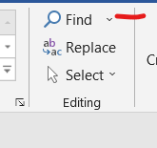
A Navigation Menu opens to the left side of the document. Type the search topic into the box:
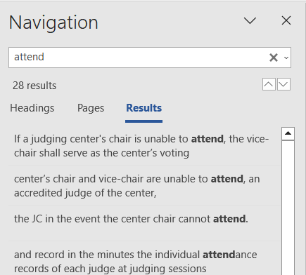

RESEARCH QUESTIONS:
- What are the responsibilities of a student judge for attendance/business meetings/out-of-region judging?
- What is a certified judge and who is considered a certified judge for nominating and having their vote count toward an AOS award (mark all that count): Emeritus judges, Senior judges, Accredited judges, Associate judges, Student judges?
- To retain your status as a student, associate, or accredited judge, you must do the following (although this is not all of the requirements). Mark all that count:
  - Be a member in good standing of the American Orchid Society, which includes a subscription to Orchids and OrchidPro
  - Subscribe to Orchid Digest
  - Attend at least eight judgings per year of which four must be a monthly judging or all duly called business meetings
  - Participate in at least 12 hours of scheduled training sessions (for example, presentations and discussion at monthly meetings, presentation at semi-annual AOS Members meetings, out-of-area training seminars, other seminars organized by orchid special interest groups, AOS webinars, etc.)
  - Wear casual clothes suitable for gardening at judging or shows
  - Conduct yourself in a manner compatible with the code of ethics and conduct as set forth in the latest edition of the Judging Handbook
  - Bring a bottle of good wine to judging
- Any judge may request a leave of absence. How does it affect time served and eligibility for promotion?
- What section of the Handbook discusses Quality Awards?
- What section discusses Ethics?
- The Glossary for Judges at the end of the Handbook lists terms, their definitions and what else? Why is that different from other botanical glossaries but useful for judges? What is a “made-up plant”? What does “according to variety” mean?
- What is a provisional award? How do we deal with provisional awards?

Note: other modules will refer to the Handbook on Judging.

